TWAHIRAH KIDS JUNIOR SCHOOL-BUSULA
P.3 END OF TERM I INTERNAL EXAMINATIONS – 2024

English

Name:___________________________________________________

SECTION A

Subsection I

In questions 1 – 2, write the given words correctly.
1. asones:_________________________ 2. hcrhcu:________________________
Write the following in words.
3. 9th:__________________________________________________________________
4. 40: __________________________________________________________________
For numbers 5 – 9, use a suitable word to fill the gaps.
5. The boy is jumping _______________________ a stone.
6. He did not have _____________________ money to pay for the sweets.
7. She has taken her shoes to the ________________________ for mending.
8. The children saw _____________________ elephant at the zoo.
9. _____________________ do the cleaners use to clean the compound?
In questions 10 – 16, use the correct form of the word in brackets to fill the gaps.
10. Mr. Muna is a _____________________ . ( farm )
11. That bag is __________________. (I)
12. The bird _____________________ over our house every morning. (fly)
13. This is the _____________________ time my uncle is going to Europe this year. (two)
14. She is _______________________ a cake for my birthday. (bake)
15. Musa’s bag is _______________________ than mine. (small)
16. They ______________ playing football now. (be)
In numbers 17 – 18, arrange the given words in alphabetical order.
17. fence, nest, basket, hand
______________________________________________________________________
18. grow, gland, get, goat
______________________________________________________________________
Write the short forms in full.
19. Rd.___________________________________________________________________
20. it’s____________________________________________________________________
21. Mar.__________________________________________________________________
22. wk.___________________________________________________________________
Rewrite giving the plural form of the underlined words.
23. Tell the child to go into the class.
______________________________________________________________________
24. The monkey is playing in the tree.
______________________________________________________________________
25. She bought a knife from the market.
______________________________________________________________________
Use the given words to write sentences to show that you know the difference in their meaning.
26. there
__________________________________________________________________
27. their
__________________________________________________________________
In numbers 28 – 30, rewrite the sentences giving the opposite of the underlined words.
28. Damba is a strong man.
______________________________________________________________________
29. He is opening the door.
______________________________________________________________________
30. He will visit his uncle in the first term holiday.
______________________________________________________________________

Sub-Section II
Rewrite the sentences as instructed in brackets.
31. The baby is crying. He is hungry.
( Join the sentences using: ………………because………………….. )
______________________________________________________________________

32. Musa saw a snake. He cried.
(Join the sentences using: ………………when……………. )
______________________________________________________________________
33. He worked hard. He failed the exam.
( Join the sentences using: …………………….,.but……………………... )
______________________________________________________________________
- There is no water in the pot.
( Rewrite the sentence using: ……………any …………………… )
______________________________________________________________________
- She has a bag. She has a mat.
( Join the sentences using: ………………… and ……………….. )
______________________________________________________________________
- Kapere is tall. Kampi is very tall.
( Join the sentences using: ……………………….than……………………... )
______________________________________________________________________
- There isn’t any food in the store.
( Rewrite the sentence using:……………..………some………………………… )
______________________________________________________________________
- She ate the cake yesterday.
( Rewrite the sentence ending: ………………………………now. )
______________________________________________________________________
- Farmers borrow money from banks.
( Rewrite the sentence beginning: Banks……………………………………. )
______________________________________________________________________
- The captain scored goal number one in the match.
( Rewrite as the sentence using: ……………………. first ………………………… )
______________________________________________________________________
- Teddy is shorter than Ali. ( Rewrite beginning: Ali ……………………………….. )
______________________________________________________________________
- The boy was hungry. He bought a mango and ate it.
( Join into one sentence using:……………….………, so…………………………. )
______________________________________________________________________

- Mustafa is nine years old.
( Rewrite the sentence beginning: How …………………………………...?)
______________________________________________________________________
- The story book belongs me.
(Rewrite the sentence ending: ……………………………………………………………mine)
______________________________________________________________________
- janthan bought a pen a book and a rubber
(Rewrite and punctuate the sentence correctly.)
______________________________________________________________________
- Planting is done before harvesting.
( Rewrite the sentence using: …………………………..after………………………... )
______________________________________________________________________
- He is the boy. He lost his bag.
( Join into one sentence using: ………………… who ………………………………………. )
______________________________________________________________________
- Our teacher hates like lazy pupils.
(Rewrite the sentence using: …………………… doesn’t …………………………………….)
______________________________________________________________________
- Tom is a boy. Sam is a boy.
(Join into one sentence beginning: Both …………………………………………………….)
______________________________________________________________________
- This is a mango.
( Rewrite the sentence beginning: These………..………………………………)
______________________________________________________________________

Section B
51. Read the story and answer the questions that follow in full sentences.

Mr. And Mrs. Muto’s Family
Mr. Muto lives at Bukoto. He is a doctor. He treats sick people at Kawempe Clinic. His wife is a teacher at Muyembe Primary School. Mr. and Mrs. Muto have four children. The eldest child is Jane. She is 12 years old. She is in P. 4. The second child is Peter. He is 9 years old. He is in P. 3. He likes playing football with his friend, David. Sarah follows Peter. She is 5 years old. She is in P. 1. The last-born is Amos. He is one year old. He stays at home with a maid because he is very young.
Questions:
(a) What is the story about?
______________________________________________________________________
(b) Where does Sarah live?
______________________________________________________________________
(c) What does Mr. Muto do at Kawempe Clinic?
______________________________________________________________________
(d) Where does Amo’s mother work?
______________________________________________________________________
(e) Who looks after Amos when his mother goes to work?
______________________________________________________________________
(f) In which class is Peter?
______________________________________________________________________
(g) How old is Jane?
______________________________________________________________________
(h) Who is the third born in Mr. Muto’s family?
______________________________________________________________________
______________________________________________________________________
(i) How many sons does Mrs. Muto have?
______________________________________________________________________
______________________________________________________________________
(j) Why do you think Amos does not go to school?
______________________________________________________________________
______________________________________________________________________
52. Read the poem below and answer the questions that follow in full sentences.
When rains fall daily,
The wet season has come
Farmers get seeds and hoes
New crops to plant and grow
School children get umbrellas
To hide from rain water
And women get pots and jerrycans
To collect water from the rain.
When the sun shines daily,
The dry season has come
Farmers get sickles and knives
To harvest millet, maize and sorghum
School children get water bottles
To carry water for drinking
The women stand under big trees
To hide from the sun.
(by Mary Mutono P.3 D)
Questions.
- Who wrote the poem?
____________________________________________________________________________________________________________________________________________
- What season is mentioned in the first stanza?
____________________________________________________________________________________________________________________________________________
- In which class is the writer of the poem?
______________________________________________________________________
- What tool do farmers use when it rains?
____________________________________________________________________________________________________________________________________________
- Why do farmers in the first stanza get seeds?
__________________________________________________________________________________________________________________________________________________________
6. How are umbrellas useful to the school children?
______________________________________________________________________
7. What do women use to collect rainwater?
______________________________________________________________________
8. Which word or words can be used in place of ‘daily’ in the poem?
______________________________________________________________________
9. How many crops are mentioned in the second stanza?
______________________________________________________________________
10. Why do school children carry bottles?
______________________________________________________________________

53A. Re-arrange the sentences below in the correct order to make a meaningful story.
(a) After greeting her mother, she puts off her uniform.
(b) Lastly, she does her homework.
(c) Mary goes home in the evening.
(d) When she reaches home, she greets her mother.
(e) Then, she drinks tea after dressing up.
(a) ______________________________________________________________________
(b) ______________________________________________________________________
(c) ______________________________________________________________________
(d) ______________________________________________________________________
(e) ______________________________________________________________________
53B. Read the conversation and answer the questions about it in full sentences.
Juma: Good morning, Ali.
Ali: Good morning, Juma.
Juma: Where are you going?
Ali: I am going to the library.
Juma: May I borrow your pen, please?
Ali: I am sorry, Juma. I cannot give it to you. I gave it to Peter.
Juma: It is okay. Let me get one from Mary.
Ali: Good luck. Goodbye.

Questions
1. How many people are taking part in the conversation?
______________________________________________________________________
2. During which time of day did Ali talk to Juma?
______________________________________________________________________
3. Where was Ali going when the conversation was held?
______________________________________________________________________
4. What did Juma want to get from Ali?
______________________________________________________________________
5. Why didn’t Ali give the pen to Juma?
______________________________________________________________________

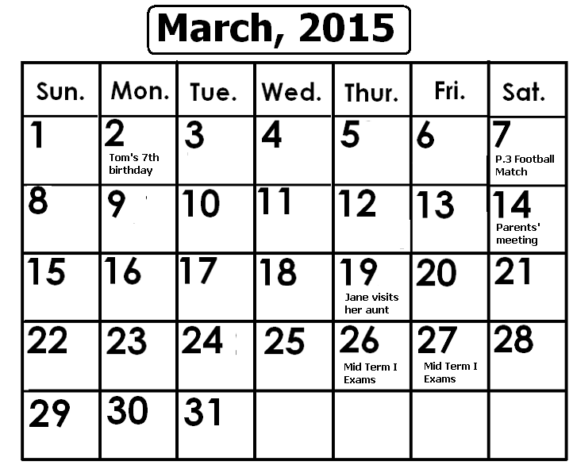54. Study the calendar and answer the questions that follow in full sentences.

(a) Which month is shown on the calendar?
______________________________________________________________________
(b) Which month follows the one shown on the calendar?
_____________________________________________________________________
(c) How many days does the month on the calendar have?
______________________________________________________________________
(d) On which day of the week did the month begin?
______________________________________________________________________
(e) How old was Tom on the 2nd of the month?
______________________________________________________________________
(f) What happened on the 27th of the month on the calendar?
_____________________________________________________________________

(g) When did Jane visit her aunt?
______________________________________________________________________
(h) How many Sundays were in the month on the calendar?
______________________________________________________________________
(i) Why did P. 3 children go to school on Saturday 7th?
______________________________________________________________________
(j) Write Wed. in full.
______________________________________________________________________
55A. Use the words below to fill the gaps in the story.
seeds, there, harvest, two, when

There are _______________seasons in a year. The wet season starts ____________it rains for a long time. Farmers grow crops because ________________is a lot of water in the soil. The dry season starts when it shines for a long time. Farmers ________________crops because there is heat to dry the___________________.
55B. Use the given words to fill in the gaps in the story.
animals, goats, examples, give, our

Domestic _________________are kept at home. Cows, _______________and dogs are ___________________of domestic animals. Some domestic animals _________________us milk and meat. Dogs keep_________________ homes safe.

